TASK – 11

- 10 Linux commands
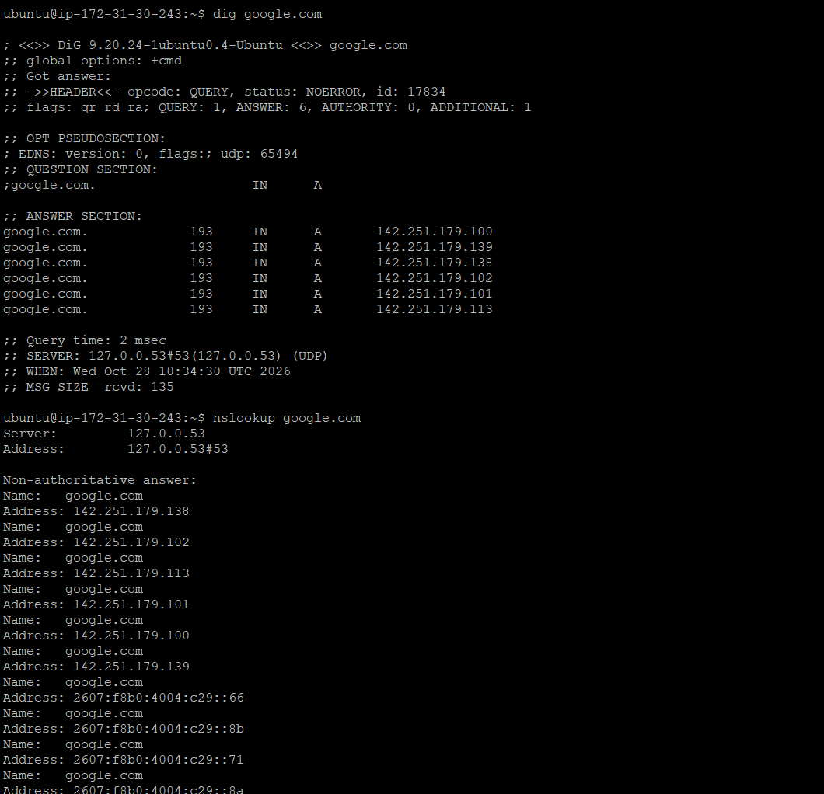
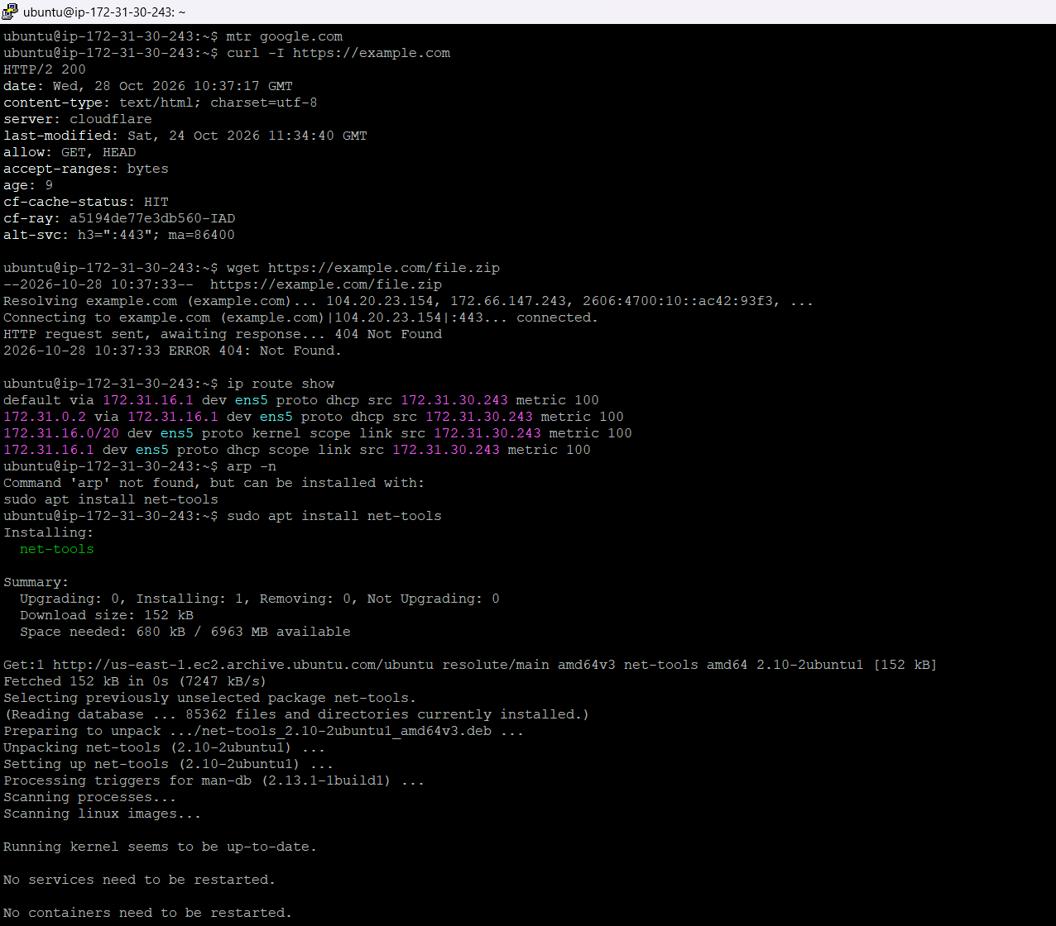
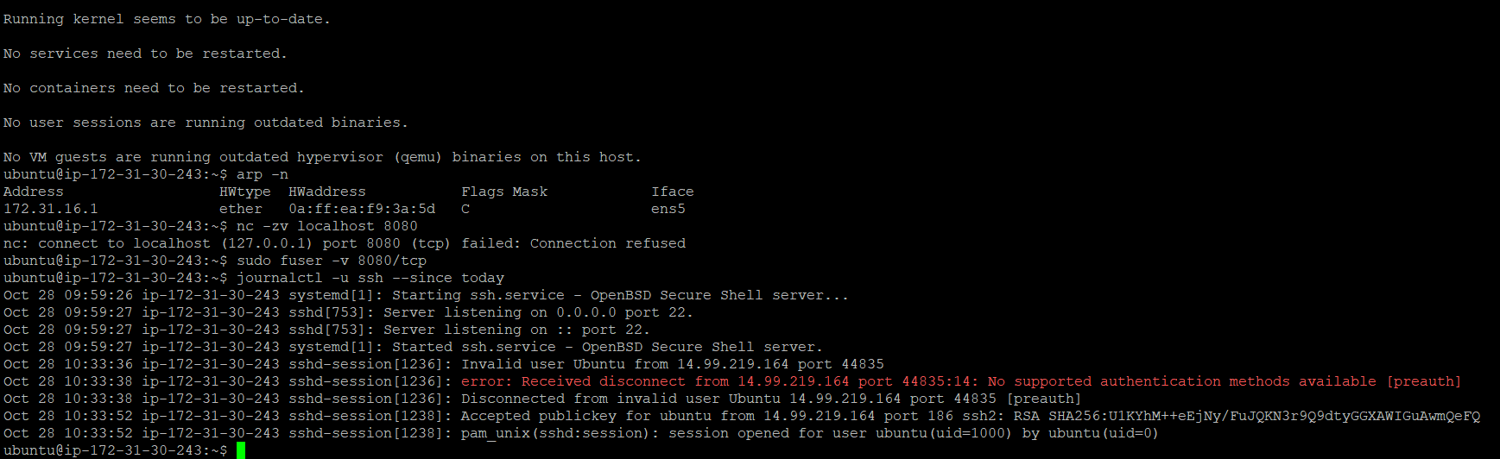
- Complete the review operations (15 operations) on Ecommerce Dataset
(Refer the file - 15_Operations_ECommerce.ipynb)
- E-commerce Data Analysis Using Pandas
(Refer the file - Data_Analysis_ECommerce.ipynb)

